STRATEGIC PLAN of NAFAN
2022-2026



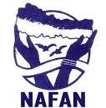

National Forum For Advocacy Nepal
Center Office
Babarmahal, Kathmandu, Bagmati Province Nepal
Branch Office :
Manohari RM, Makwanpur, Bagmati Province Nepal
Contact: +977 -9851074770
E-mail: nafannepal8@gmail.com
www.nafannepal.org.np
Table of Contents
Content Page No.
SITUATION ANALYSIS ……….……………………………………………………..……………3-4
National Forum for Advocacy Nepal (NAFAN)……………………………………….……………4-6
INTRODUCTION
VALUES
VISION
MISSION
GOAL
ORGANOGRAM
MAJOR ACTIVITIES AND ACHIEVEMENTS
STRATEGIC ISSUES………………………………………………………………………………..………………6
Programmatic Issues
Organizational issues
STRENGTHS OF NAFAN…………………..…………..…………………………………………6
CHALLENGES FOR NAFAN……………………………………………….……………………..7
PERCEIVED OPPORTUNITIES FOR NAFAN…………………………………………………….7
PERCEIVED THREATS FOR NAFAN……………………………………,……………………….7
OBJCTIVES………………………………… ……….……………………………………………..8-9
LESSION LEARN……………………………………………………………………………………..10
STRATEGIES…………………………………..……………………………………………………..11
1. SITUTATION ANALYSIS
People and their lives have always been in the core of every development intervention. Many factors/elements play major role in defining the quality of peoples’ life. It is the function of several characteristics that constitutes different aspects of peoples’ life and includes not only those physical/physiological characteristics (such as housing, clothing, access to water and sanitation, health, education etc.) but also other physiological and emotional aspects (such as achievement, affection, intellectual stimulation, sense of self worthiness etc.).
The Nepali economy is largely agrarian and increasingly impoverished characterized by unequal land holding where majority of the poor are without land holding or unproductive land. Nepal is relying on subsistence farming. Nepalese Youths have made tremendous sacrifice in every democratic movement. The youth energy has been invaluable power in any social transformation process.
17.4 % of the population of Nepal lives below the poverty line (Multi dimensional poverty index 2019). Nepali society is highly stratified and ethnically diversified. Social and power structures institutionalized through the caste systems, stratified individuals into unequal position from and by birth, Caste, creed, gender, social and economic status discriminations are deeply ingrained and are very difficult to over come by making it inclusive.
Nepal is prone to many environmental disasters (such as, landslides, floods, and earthquake. Drug and HIV/AIDS have threatened peaceful living.
Evidences of impacts of climate change on peoples’ life have posed another challenge.
COVID19 is one of the major dimensions in itself while it also has implications in other dimensions for effective service delivery. 3 years long COVID pandemic and the government response through health protocol and other facility have negatively changed the economic situation of Nepal. By the COVID pandemic socio-economic situation of the country in general turned into doldrums. Several industries were shut down. Export trade reduced. Tourism industry was handicapped. Foreign investments on all sectors remained free zed, leaving the whole economy almost paralyzed.
In the prevailing poverty situation the poor Nepali youth could find no other choice than to go abroad for safety and better income opportunities. The department of foreign employment says approximately three million Nepalese have migrated to countries other than India for work born through regular and irregular channel (THT-Sept. 2010). The trend is still in progression.
There is a diverse migration pattern in Nepal First; there is substantial internal migration from rural to urban and even within rural areas, driven by poverty and the search of jobs and better earnings. Second, there is cross border migration mainly to India. Third Nepalese youths move to Middle East and Asian countries for temporary employment. Fourth there is also a flow of skilled emigration to developed countries.

National Forum for Advocacy Nepal (NAFAN)
Introduction

National forum for Advocacy Nepal (NAFAN) is a social organization which was formally established in 2004 (2063BS) by the professional, academician, expert, campaigner who have keen interest to undertake advocacy and carry out development initiatives in Nepal/activities in different fields on behalf of Nepal’s civil society. NAFAN has been working on various thematic issues such as environment, sustainable development human right, peace building and other cross cutting issues. This organization has been prioritizing the issues of peoples right on resources by effective, efficient, and managed advocacy procedure for the improvement of livelihood of backwarded, poor and marginalized community. NAFAN has been working in the field of environmental conservation, sustainable resource management and its equitable distribution and capacity building, promoting gender equity and equality. Currently, NAFAN is partnering with Swallows Finland, Rydam Foundation, Raksirang Gaunpalika and other organizations for various initiatives in Nepal.

Our Vision
Peace and prosperity of the nation and environmental conservation.

Our Mission
Influence, encourage and shape the plan, policies and decisions in political, social, economic and environmental dimension

Our Goal
Action oriented national level initiation that supports to strengthen individual advocacy goals through collective advocacy and information sharing.

Objectives
- Protection, promotion, and realization of human rights of socially and economically marginalized people and community
- Protection, promotion and realization of the cultural and economic right of different class and community
- Access of marginalized class to environment, natural resources and biodiversity
- Provide proportionate share to the disadvantaged community, and local groups of the benefits arising from commercial and other utilization of natural or biological resources
- Conduct different activities to ensure rights of women and mainstreaming gender
- Decentralization of natural resource management, conservation, sustainable use it and management of biodiversity to the local level of the society and local government
- Establish and promote good environmental governance
- Act as a resource center

ORGANOGRAM
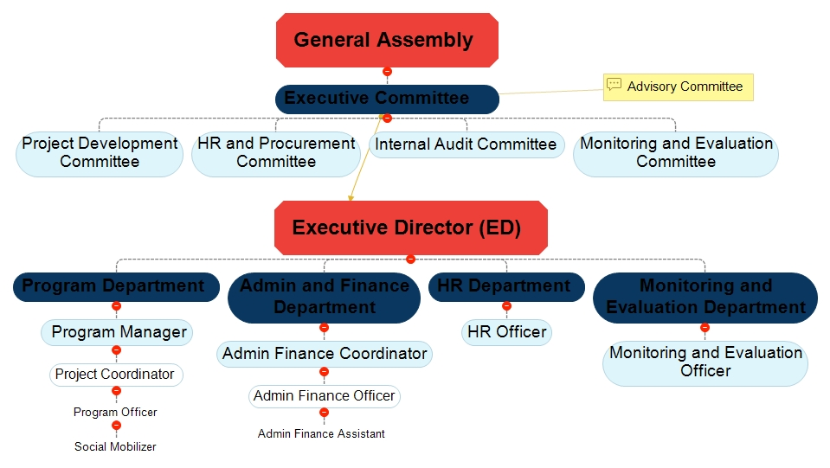

VALUES
- Mutual respect and solidarity
- Participation and active involvement
- Equity, equality and inclusion
- Transparency and accountability
- Democracy and human rights
- Collaboration and Collective leadership
- Peaceful social transformation
- Decentralized decision
- Biasness
- Local resource mobilization

Historical Trend Analysis of NAFAN
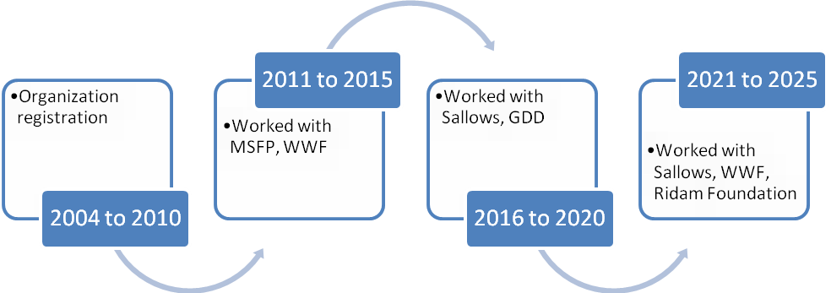

MAJOR ACHIEVEMENTS of NAFAN
- Policy contribution on land, water, forest and climate change
- Huge publication on natural resource management
- Known as a policy advocacy organization
- Trusted by donor and program operation capacity
- Currently managing 15 staffs and secured fund for next 3 years

STRATEGIC ISSUES for 2022 to 2027
a. Programmatic issues: on the basis of theme:
NAFAN
Natural Resource Management
Resilience Livelihood

Policy Research & Advocacy
DRR & CCA
Human Rights, Good Governance an& Accountability
Advocacy
Development

b. Organizational Development Issues
  - Organizational Management and Development
  - Resource Mobilization and Financial Sustainability
  - Policy Research and Advocacy
  - Program Collaboration and Issue Based Networking

SWOT Analysis
STRENGTHS OF NAFAN
- Focused on specific objectives
- Based on natural resource management
- Owned by local people
- Policy advocacy organization
- Competencies on capacity building
- Focused on indigenous knowledge
- Know rhetoric and reality/ professional
- Program focused on target group
- Strong history
- Good reputation an trusted by donor
- Multiple publication
- Efficient and effective resource mobilization capacity
- Led by expert
- Technology friendly office environment

CHALLENGES FOR NAFAN
- Limited capacity of board members
- Limited working areas
- Less diversified member
- Less networking and coordination with stakeholder
- No internal fund
- Lack of full time staff
- Lack of common understanding
- Lack of proper documentation skill
- Limited operational policies and guideline

PERCEIVED OPPORTUNITIES FOR NAFAN
- An opportunity to work with 761 governments
- Able to contribute to achieve the Sustainable Development Goal (SDGs)
- Huge issues of PVSE
- High opportunity to travel around the world
- Space for policy advocacy with central and provincial government
- High opportunity to create employment opportunities

PERCEIVED THREATS FOR NAFAN
- Complicated tax system
- Political instability in the country
- Political tag and politization of issues
- High expectation from communities and stakeholder
- Safety issues of staff

5 Years Visioning
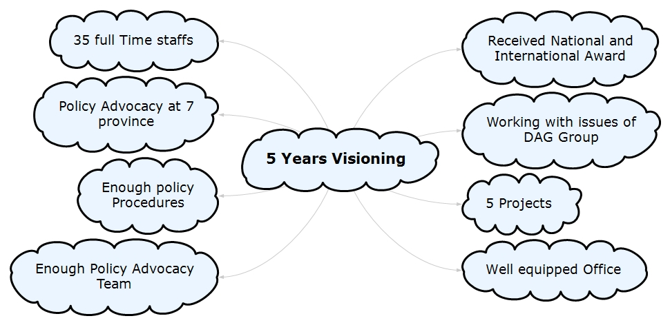

Thematic Priorities and Defined Activities for 2022-2027)
Thematic Priorities | Major Activities | Annual Target | Proposed Budget for each year |  | Potential Donors
Natural Resource Management | - Provide Entrepreneurship Development Training  - Support Seed money for their entrepreneurship  - Marketing  - value Chain Analysis |  |  |  | WWF, GEF, Practical Action, Sallow Foundation,
Resilience Livelihood | - Provide Entrepreneurship Development Training  - Support Seed money for their entrepreneurship  - Marketing  - value Chain Analysis |  |  |  | Sallow Foundation, DCA, UNDP
Human Right and Good Governance and Accountability | - Interaction and Discussion  - Public Hearing and Social Audit  - Promote Human Rights and respect others dignity  - Training and research |  |  |  | Human Right commission, UN agencies, Asia foundation, US Embassies, EU,
DRR CCA | - Interaction and Discussion  - Public Hearing and Social Audit  - Promote Human Rights and respect others dignity  - Training and research |  |  |  | TAYAR, ministry of home, various organization
Policy Research and Advocacy | - Policy research on NRM, Human rights, Law on forest, land and water  - Government lobby and Advocacy at central, regional and local government  - Capacity building on Research and advocacy |  |  | US embassies, EU, Koica, World Bank,
Institution Development | Activities
- Enhancing organizational capacity | - Expand membership in each year  - develop Human Resource Development Unite  - Develop Programme Develop Unit  - Provide Baseline survey, Report Writing, Proposal Writing, M&E training  - Well -Equipped furniture and Furnishing
- Resource mobilization and financial sustainability | - Local resource mobilization  - best utilization of organizations expertise  - Create organization core fund
- Promoting transparency and accountability | - Public Audit  -Regular audit
- Program collaboration and issue based networking | - Network and coordination with other stakeholder and like minded organization for youth participation  -Lobby for betterment of life and people dignity
- Coordination, communication and relationship building | - Regular communication with other stakeholders  - Regular communication with Donor and Development aid organization  - Communication tools can be Phone, Internet, Email as per suitability
- Enhancing organizational capacity | - HRD  - Strengthen Administrative and Financial policy  - Develop Communication Policy  - Develop code of conduct for staffs and members  - follow the best practice of organization

What should change in Organization -Structure, Policies, Culture and values?
  - Research as a continuous process of Organization through Organization Development Desk
  - Human Resource Development policies formation
  - Develop Partnership, Fundraising & Program Policy
  - Series of Interaction and discussion between line agencies and Stakeholders
  - Public Audit

Future collaboration and coordination:
Relation | Coordination | How?
- NPC, Minitry of Forest, Ministry of Land, Ministy of Labour, other ministires, department, province government and local government | - Dialogue  - Human Resource mobilization  - Resource Mobilization | - Quarterly Basis Interaction  - Reporting
- Donor/Partner | - Coordinate to and conduct project vision  - Human resource development and organizational development and coordinate with aid agencies | - Half yearly interaction with donor  - Monthly and yearly reporting
- NGO/Network/ CBOs | - Mutual sharing  - help to enhance capacity development  - Collaboration with organization  - Human resource mobilization  - Coordinate for organization for project implementation  - Follow the code of conduct | - Meeting  - Discourse  - Workshop  - Training  - Report submission
- Private sector | - Business Training and encourage in entrepreneurship  - Invest in Social sector and social work  - Rescue and Relief Support | - Regular meeting with FNCCI, Corporate House
- media | - Update our learning , progress and Issues through media  - Explore Human right violation related issues through media  - Conduct radio programme and other sectoral programme in Media as tools of information | - Press Conference  - Website  - programme report
- Target Group | - Baseline Survey and Programme Development  - Ensure community participation in programme | - Coordination and Collaboration among community
- Develop Research and Advocacy Team | - NEPAN  - FECOFUN  - Indian Library  - ACOFUN  - INSEC  - Human Right Commission | - Proposal Development and regular meeting

Lesson Learnt form Strategic plan

  - Develop baseline survey and effective monitoring and evaluation mechanism
  - Timely review and target setup

Thank you

